**Windy City Diving Dryland Training Center**

Signature Gymnastics Academy

2246 Palmer Drive Suite 107

Schaumburg, IL 60173

**SPRING 23 TRAINING INFORMATION**

February 14, 2023 - April 26- 2023

Participant must complete three requirements:

1. United States Diving current membership
2. Windy City Diving team membership
3. Signature Gymnastics Academy signed waiver.

When: Tuesday and Wednesday Groups 7-8:30pm

Tuesday Group: 7-8:30 pm

Wednesday Group: 7-8:30 pm

Dryland availability days by week:

Tuesdays. Wednesday’s

Week 1: 2/14/23 2/15/23

Week 2: 2/21/23 2/22/23

Week 3: 2/28/23 3/1/23

Week 4: 3/7/23. 3/8/23

Week 5: 3/14/23. 3/15/23

Week 6: 3/21/23. 3/22/23

Week 7: 4/4/23. 4/5/23

Week 8: 4/11/23. 4/12/23

Week 9: 4/18/23. 4/19/23

Week 10: 4/25/23. 4/26/23

Fees:

One day per week = $ 300.00 , DROP IN $35.00

Two days per week = $ 550.00, DROP IN $35.00

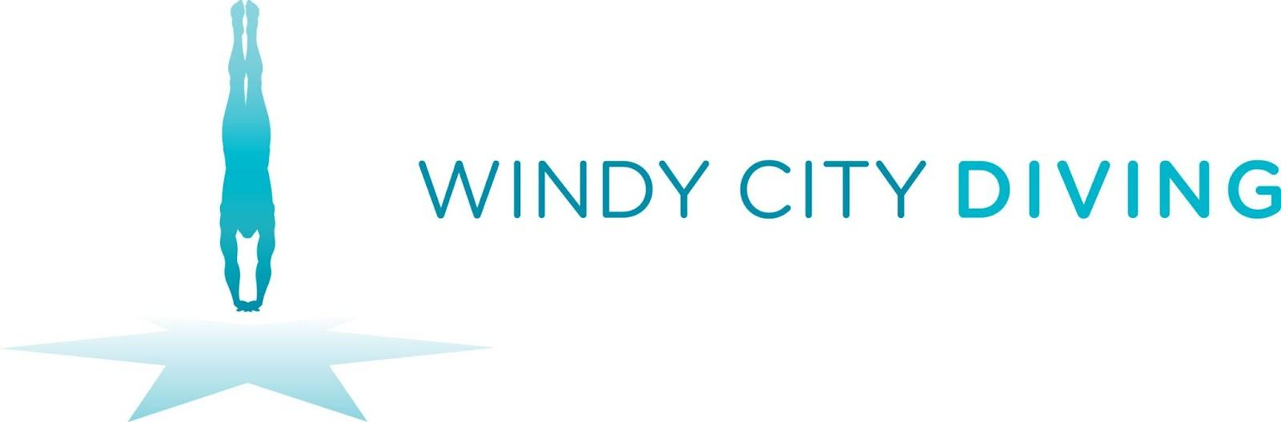



**Dryland Registration form: SPRING 23**

Diver Name:_______________________________________

Diver e-mail: ________________________@______._______

Parent e-mail:________________________@______._______

Parent: Emergency Phone#: ___________________________

Training Day: (circle one) 7-8:30 pm all days

Tuesday. Wednesday. All.

**Checks made payable to: Windy City Diving Team**

Send via mail or bring to FIRST Session:

Windy City Diving Team

1139 Gordon Terrace

Deerfield, IL 60015